Telstra Essential Smart 4

Type of device: Mobile
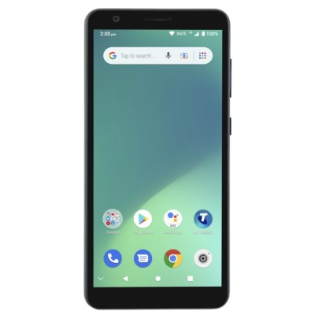

Actual Display Size : 5.5 inches
Button Type : Touchscreen
Operating System : Android
Version Number : Android R GO
Network Capability : 3G,4G
Year of Release : 2022
Average Price : $109 as of 30 11 2022

Accessibility Features:

Cognitive
- Additional Instructions
- GPS
- Photo Telephone List
- Screen Timeout Disabled
- Simple Instructions
- Simple Reminders
- Simplify Display
Voice Notes

Hearing Impairment and Deaf
- Bluetooth or Wi-Fi
- Closed Captioning
- Front Facing Camera
- Text Messaging/SMS
- Vibrating Alerts - Adjustable
- Video Communications - Two-way
Visual Alerts - Incoming Calls

Vision
- Battery Alert - Audible
- Bluetooth or Wi-Fi
- Braille Display Support
- Brightness Adjustable
- Dictation / Speech-to-Text
- High Contrast Mode
- Power Cue
- Screen Magnifier
- Screen Reader
- Text Size Adjustable
- Text Style Adjustable
- Voice Control /Personal Assistant
Voiced Menus

Speech
- Allows for sign language communication
- Bluetooth or Wi-Fi
- Messaging Options - Email
- Messaging Options - IM
- Messaging Options - MMS
- Predictive Text
SMS Personalisation and Reuse

Physical
- Automatic Answer
- Bluetooth or Wi-Fi
- Dictation / Speech-to-Text
- Headset - plug connected
- Predictive Text
- Speaker-phone option
- Stylus or Prosthetic Device support
- Switch control option
- Voice Control / Personal Assistant
- Voice Recognition for Accessing Features
Voice Recognition for Dialling

How and where to get it from?
You can buy this phone from Telstra, Officeworks, Big W, Australia Post, and other retailers.

More information is available on:
Telstra Essential Smart 4 webpage

